SCHOOLOFCOMPUTER SCIENCE AND ARTIFICIAL INTELLIGENCE |  |  |  |  | DEPARTMENTOFCOMPUTER SCIENCE ENGINEERING
Program Name: B. Tech |  |  |  | Assignment Type: Lab |  |  | Academic Year:2025-2026
Course Coordinator Name |  |  |  | Dr. Rishabh Mittal
CourseCode |  |  | 23CS002PC304 | Course Title |  | AI Assisted Coding
Year/Sem |  |  | III/II | Regulation |  | R23
Date and Day  of Assignment |  |  | Week3 – Wednesday | Time(s) |  | 23CSBTB01 To 23CSBTB52
Name |  |  | Syed mashood adnaan | Batch : |  | 47(b)
AssignmentNumber:9.3(Presentassignmentnumber)/24(Totalnumberofassignments)
H.NO:2303A54017
 | Q.No. | Question |  |  |  |  |  | ExpectedTi me  to  complete
Lab 9: Documentation Generation – Automatic Documentation and Code Comments Lab Objectives
- To understand the importance of documentation and code comments in software development
- To explore how AI-assisted coding tools generate documentation and inline comments
- To practice generating function-level and module-level docstrings automatically
- To evaluate the quality and accuracy of AI-generated documentation
- To develop a small automated documentation generator in Python
 | 1 | Lab Outcomes (LOs)  After completing this lab, students will be able to:  - Apply AI-assisted coding tools to generate docstrings and inline comments  - Analyze AI-generated documentation for correctness and readability  - Create structured documentation using standard formats (Google, NumPy)  - Design a mini documentation generation tool  Task 1: Basic Docstring Generation Scenario  You are developing a utility function that processes numerical lists and must be properly documented for future maintenance.  Prompt : Create a Python function named sum_even_odd(numbers) that takes a list of integers and returns a tuple containing the sum of even numbers and sum of odd numbers.  - First, write the function with a manually written Google Style docstring including:  - Description  - Args  - Returns  - Example  2. Then generate an AI-style Google docstring for the same function separately (without changing logic). |  |  |  |  |  | Week4 - Wednesday

- Provide a structured comparison analyzing:
  - Clarity
  - Correctness
  - Completeness
  - Readability

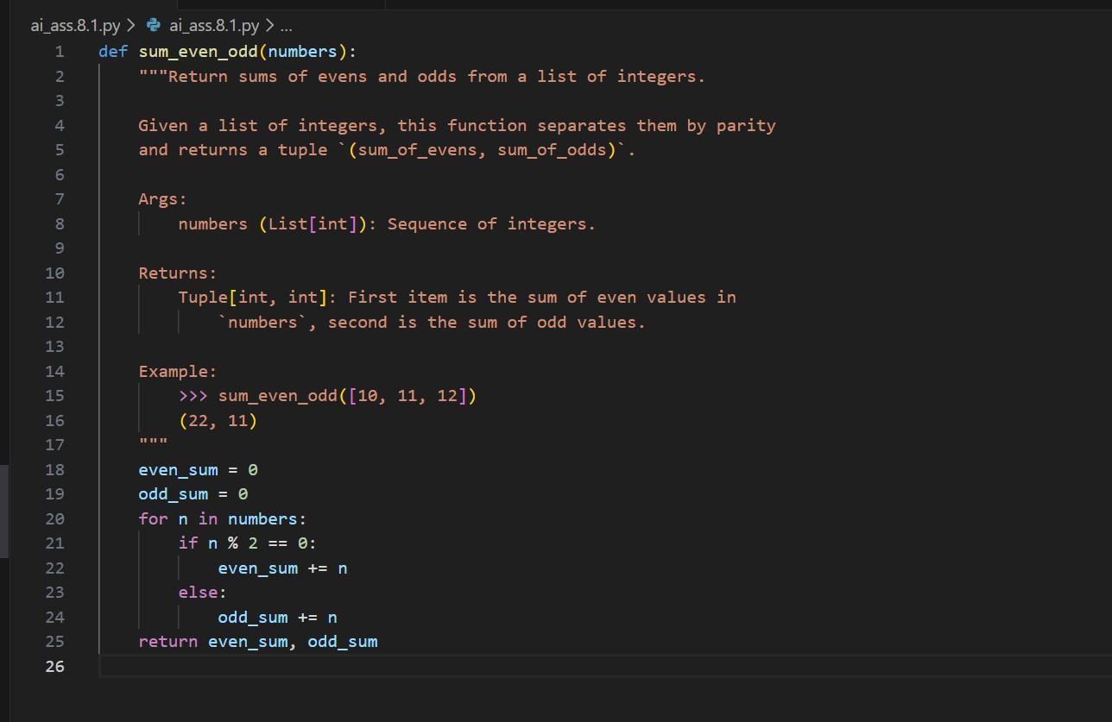
Ensure the code runs without errors. Code :

Requirements
- Write a Python function to return the sum of even numbers and sum of odd numbers in a given list
- Manually add a Google Style docstring to the function
- Use an AI-assisted tool (Copilot / Cursor AI) to generate a function-level docstring
- Compare the AI-generated docstring with the manually written docstring
- Analyze clarity, correctness, and completeness
Expected Output
- Python function with manual Google-style docstring
- AI-generated docstring for the same function
- Comparison explaining differences between manual and AI-generated documentation
- Improved understanding of AI-generated function-level documentation
Explanation : In this task, we create a function sum_even_odd(numbers) that finds the sum of even and odd numbers from a list and returns them as a tuple. The main focus is writing Google Style docstrings manually and then generating an AI-style docstring for the same function. Finally, both docstrings are compared based on clarity, correctness, completeness, and readability.
Task 2: Automatic Inline Comments Scenario
You are developing a student management module that must be easy to understand for new developers.
Prompt : Create a Python class named sru_student with:

Attributes:
- name
- roll_no
- hostel_status

Methods:
- fee_update(amount)
- display_details()
- First, write the class with detailed manual inline comments explaining each line or logical block.
- Then generate an AI-assisted version of inline comments for the same code (without changing logic).
- Provide a comparison discussing:
  - Missing comments
  - Redundant comments
  - Incorrect explanations
  - Strengths and limitations of AI-generated comments Ensure the program runs without errors.
Code :
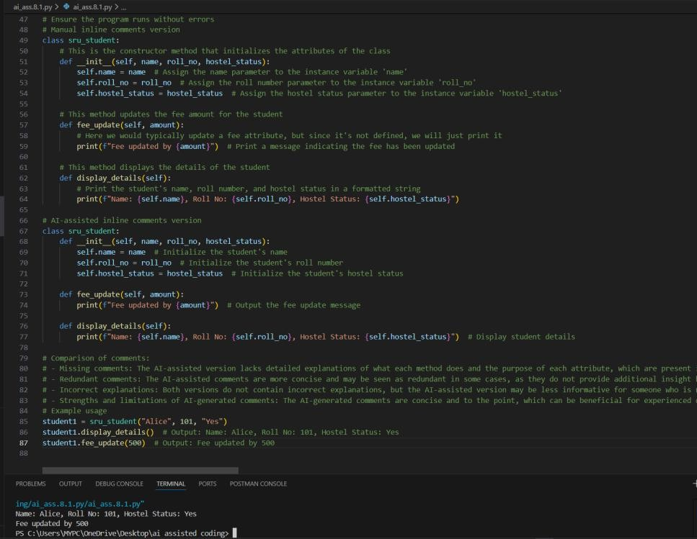
Requirements
- Write a Python program for an sru_student class with the following:
- Attributes: name, roll_no, hostel_status
- Methods: fee_update() and display_details()
- Manually write inline comments for each line or logical block
- Use an AI-assisted tool to automatically add inline comments
- Compare manual comments with AI-generated comments
- Identify missing, redundant, or incorrect AI comments
Expected Output
- Python class with manually written inline comments
- AI-generated inline comments added to the same code
- Comparative analysis of manual vs AI comments
- Critical discussion on strengths and limitations of AI-generated comments
Explanation : In this task, we create a class sru_student with attributes like name, roll number, and hostel status, and methods to update fees and display details. First, the code is written with detailed manual inline comments. Then
AI-generated comments are written for the same code. Finally, we compare

both comment styles and analyze missing, redundant, and incorrect comments.
Task 3: Module-Level and Function-Level Documentation Scenario
You are building a small calculator module that will be shared across multiple projects and requires structured documentation.
Prompt: Create a Python calculator module containing four functions:
- add(a, b)
- subtract(a, b)
- multiply(a, b)
- divide(a, b)

- First, manually write NumPy Style docstrings for each function including:
  - Parameters
  - Returns
  - Raises (for divide by zero)
  - Example
- Then generate:
  - A module-level docstring
  - AI-generated NumPy Style function-level docstrings (without modifying function logic)
- Provide a structured comparison evaluating:
  - Structure
  - Accuracy
  - Completeness
  - Readability
  - Professional quality

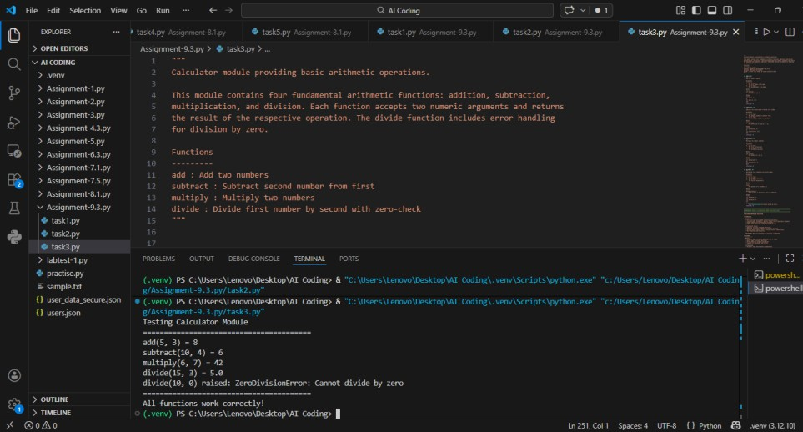
Ensure the code runs without errors. Code :

Requirements
- Write a Python script containing 3–4 functions (e.g., add, subtract, multiply, divide)
- Manually write NumPy Style docstrings for each function
- Use AI assistance to generate:
- A module-level docstring
- Individual function-level docstrings
- Compare AI-generated docstrings with manually written ones
- Evaluate documentation structure, accuracy, and readability
Expected Output
- Python script with manual NumPy-style docstrings

- AI-generated module-level and function-level documentation
- Comparison between AI-generated and manual documentation
- Clear understanding of structured documentation for multi-function scripts

Explanation : In this task, we create a calculator module with functions add, subtract, multiply, and divide. Manual NumPy Style docstrings are written for each function, including parameters, returns, raises, and examples. Then AI-generated docstrings and a module-level docstring are created. Finally, we compare manual vs AI docstrings based on structure, accuracy, completeness, readability, and professional quality.
Additional Requirement
- Push the complete project documentation as a .md file to a GitHub repository
- Ensure documentation covers module overview and function descriptions

Note: Report should be submitted a word document for all tasks in a single document with prompts, comments & code explanation, and output and if required, screenshots

